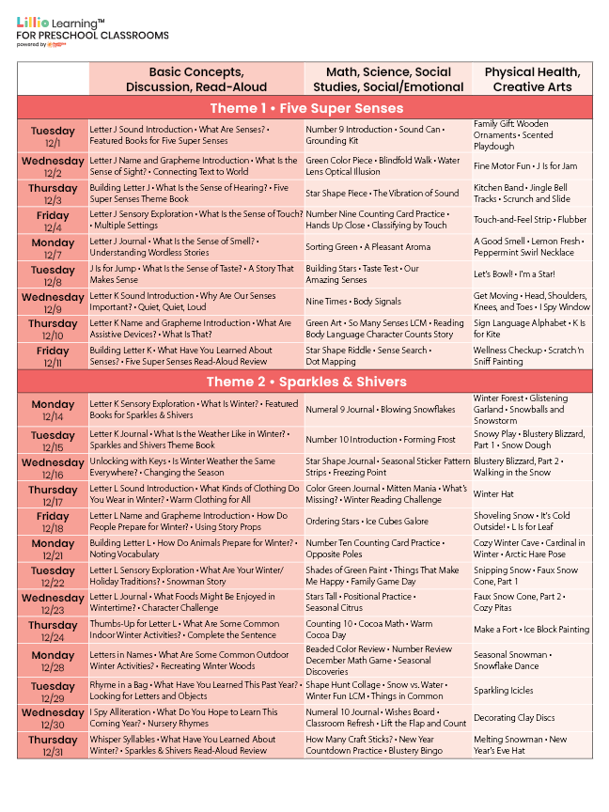
December 2026
Add Your Name/Logo Here

